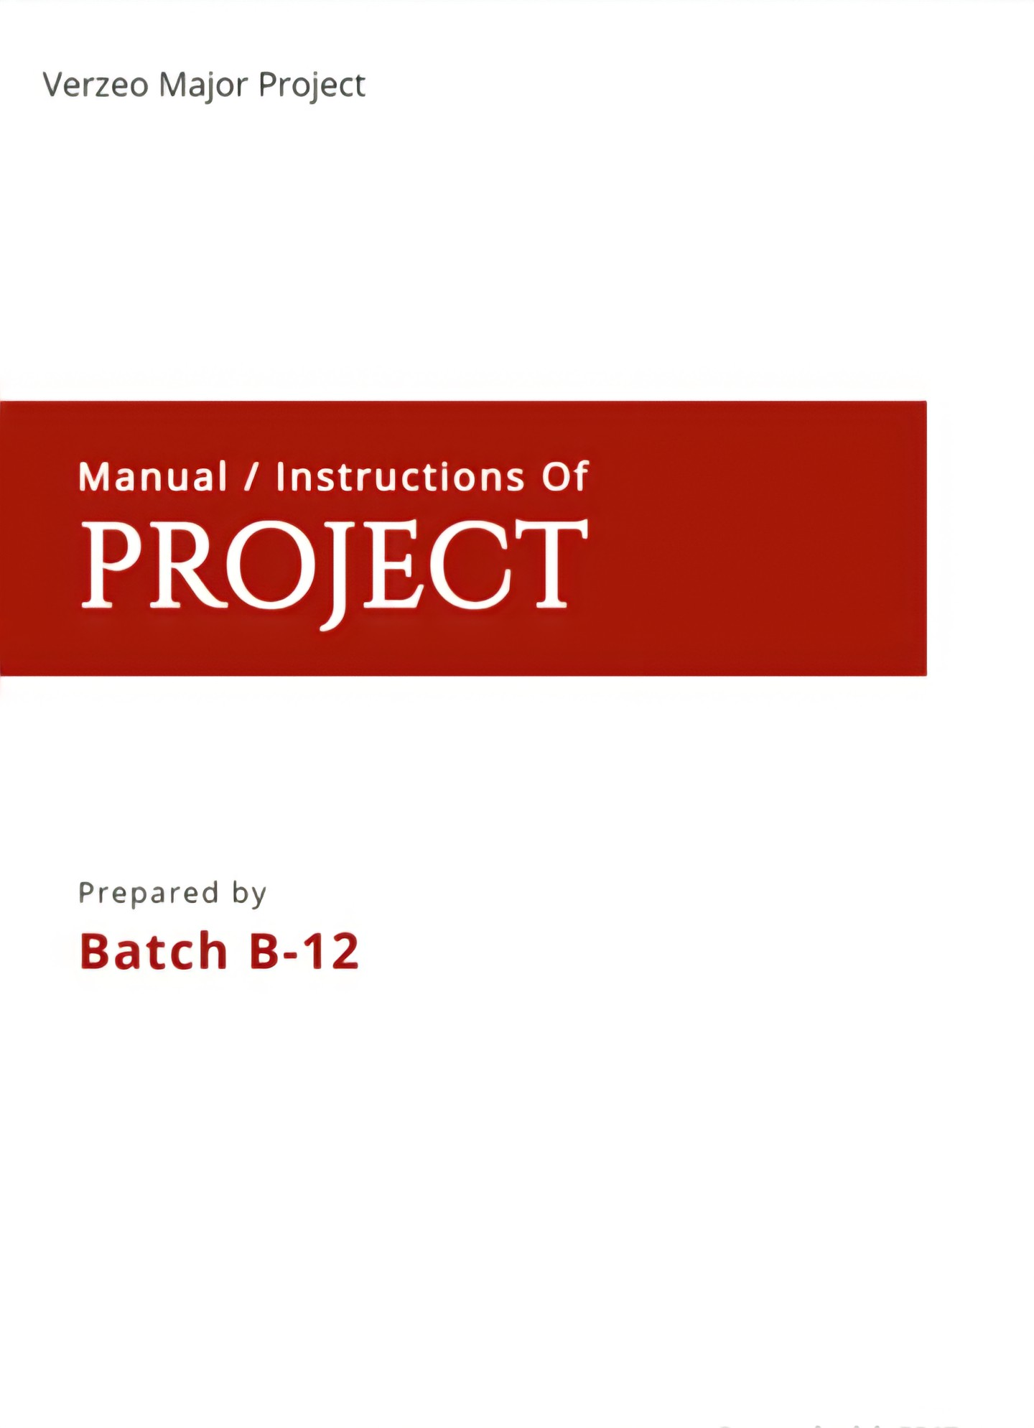SOFTWARE USED :

PYCHARM

JUPYTER NOTEBOOK

* FRAME WORK USED :

FLASK

* MODULES NEEDED TO IMPORT:

Open CV

Imutils

Numpy

Matplotlib

sklearn

Flask

* Description / Instruction

The Homepage of the website contains the login and registration tabs , about us , the contact forum and connectivity with social media , the “Get started” button takes the user to the page where they can either upload an image or paste the url of the image which the user wants to know the skin tone of.

* How to run the project

After extracting all the files ,open the project in pycharm editor. Now add python interpreter to the project and install all the above mentioned packages. Now run “app.py” file.